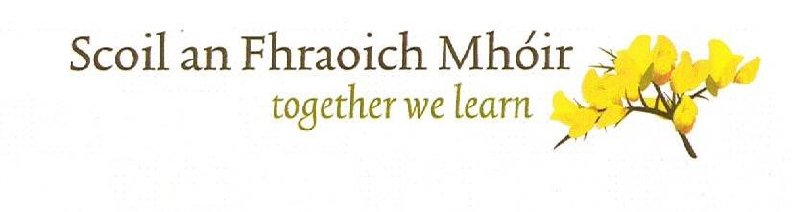
The Heath National School Raffle Terms and Conditions

- The Promoter
The Promoter is The Heath National School, The Heath, Portlaoise R32XW40. Registered Charity Number 20126223.
By entering this raffle all entrants agree to be bound by these terms and conditions and any other conditions in the messaging or promotions of this Raffle (which may be amended at any time by The Heath National School). Any entries not complying with these terms and conditions will not be valid. The terms and conditions herein are governed by Irish Law and the parties submit to the exclusive jurisdiction of the Irish Courts.
- The Prizes
The first prize is a weekend ticket to Electric Picnic 2023
The second prize is a weekend ticket to Electric Picnic 2023
The Promoter accepts no responsibility or liability to the winner for any dissatisfaction with the prize. No alternative prize will be offered. The prizes are not redeemable for cash. The winners may be subject to identity verification by The Heath National School.
- Entry Requirements
  - The Raffle will run from Monday 24th July to Thursday 24th August 2023 (closing date) inclusive.
  - Tickets can only be purchased online through the iDonate platform. Two ticket options are available, 1 ticket for €5 or 3 tickets for €10. On purchase of an online ticket for the raffle draw, all purchasers of tickets are automatically entered.
  - All income generated by the Raffle will be restricted to the provision of educational resources at the Heath National School, specifically to assist in funding the school’s Music Generation Program. If the school exceeds its target, income will go to provide other educational resources within the school.
  - The draw is open to all persons aged 18 or over as at the date of the draw. The Promoter reserves the right to reject any entry (and award the prize to an alternative winner) if it has grounds to believe the entrant has breached any of these terms and conditions, acted fraudulently or illegally, or on other reasonable grounds and shall have no liability to an entrant for any loss or damage arising from such rejection.
  - By entering the Raffle, the entrant agrees to take part in any publicity relating to the raffle draw, if invited to participate by the Promoter.
  - The Promoter reserves the right to cancel, amend, terminate or temporarily suspend this raffle at any time with no liability to any entrant or any third party. If due to unavailability of a prize, beyond the promoter’s control, the promoter reserves the right to substitute another prize of similar value.

- Winner Selection
  - The winner will be drawn on Friday 25th August in The Heath National School and will be supervised by an independent scrutineer.
  - The winners will be notified within 72 hours of the closing date by email or phone. The Promoter’s decision is final. The Promoter shall have no liability for the winner’s failure to receive notices due to spam, junk e-mail, or other security settings or for the winner’s provision of incorrect or otherwise non-functioning contact information. If the winner cannot be contacted, is ineligible, or fails to claim the prize within 48 hours from the time the winner notification is sent, the prize will be forfeited and an alternative winner selected due to the time sensitivity of the prize.

- Use of Information
The Promoter respects, and is committed to protecting your privacy. The personal information you provide will remain private and will only be used for the purposes of contacting the winners, unless otherwise requested by the individual. The winners name will be announced on the school website www.heathns.ie
- Limitation of Liability
Insofar as is permitted by law, the Promoter, its agents or distributors will not in any circumstance be responsible or liable to compensate the winner or accept any liability (under contract, or otherwise under law) for any loss, damage, personal injury or death occurring as a result of taking up the prize except where it is caused by the negligence of the Promoter, its agents or distributors or that of their employees.
If for any reason any aspect of the Raffle does not function correctly, whether by means of infection by computer virus, network failure, bugs, tampering, unauthorised intervention, fraud, technical failures or any cause beyond the control of the Promoter that corrupts of affects the administration, integrity or fairness of the Raffle draw then the Promoter may at its sole discretion cancel, modify or suspend the promotion and/or invalidate affected entries.
If you have any queries or complaints please contact the school on 0578646658 or email office@theheathns.com

