

7 week GROUP programme

(4 weekly sessions of 2 hours, followed by 2 weeks where you practice Triple P at home with support phone call sessions, we meet as a group for final session).

|  |  |  |
| --- | --- | --- |
| **Date** | **Time** | **Location** |
| **Tuesday 28th Jan 2020** | **10-12md.** | **Mountmellick Family Resource Centre**  **Co Laois.** |
| **Wednesday 29th Jan 2020** | **7-9pm.** | **Portlaoise Education Centre, Block Road Portlaoise** |

**Teen Triple P 2hr Workshops**

**Getting Teenagers to Cooperate**

|  |  |  |
| --- | --- | --- |
| **Tuesday 31st March 20** | **7-9 pm.** | **Mountmellick Family Resource Centre Mountmellick.** |

**Coping with Teenagers Emotions**

|  |  |  |
| --- | --- | --- |
| **Tuesday 24th March 20** | **10-12md.** | **Portlaoise Education Centre, Block Road Portlaoise.** |

Triple P Programmes give you tips and strategies to help parents cope positively with the challenges of raising a teenager, meet other parents and make family life more enjoyable.

**Please contact our office to book your FREE place**

**Midlands Area Parenting Partnership**

**Phone 090 6447111/ Deirdre 0860274837/Sinead 0868215102**



Tel ( 090) 64 47111

**Teen Triple P Positive Parenting** 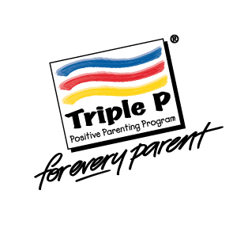

**Free courses for parents and carers of teenagers aged 11-15 years**