Senior Infants Wellness Week 15th – 19th June 2020
Monday | Tuesday | Wednesday | Thursday | Friday
Yoga:  Complete “The Very Hungry Caterpillar” Yoga video. See Seesaw for link or YouTube. | Yoga:  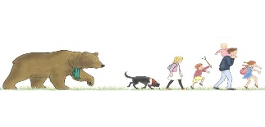  Complete “We’re Going on a Bear Hunt” Yoga video. See Seesaw for link or YouTube. | Yoga:  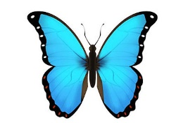  Complete “Coco the Butterfly” Yoga video. See Seesaw for link or YouTube. | Yoga:  Complete “Popcorn and the Pirates” Yoga video. See Seesaw for link or YouTube. | Yoga:  Complete “Pedro The Penguin” Yoga video. See Seesaw for link or YouTube.
Story: “Have you filled a bucket today?” Can you think of some things you could do to become a bucket filler? | Mindful Colouring: Play some calm music (see Seesaw for a link) and colour a page of your Rainy Days book. Relax and enjoy! | Meditation: Butterfly Body Scan Try this calming meditation and let your whole body relax! | Story: “The Huge Bag of Worries” Listen to the story, draw and discuss things you might be worried about with an adult, it’s good to talk! | Mindful Listening: Listen carefully with your eyes closed for one minute to all the sounds you can hear. Write down what you heard.
Rainbow Heart: Make a rainbow heart to show someone you care. | Teddy Breaths: Have a look at Seesaw for details! | Art: Draw or paint a beautiful butterfly! | Thankful Thursday: List all the things you are thankful for. | Feelings Friday: See Seesaw for details.

