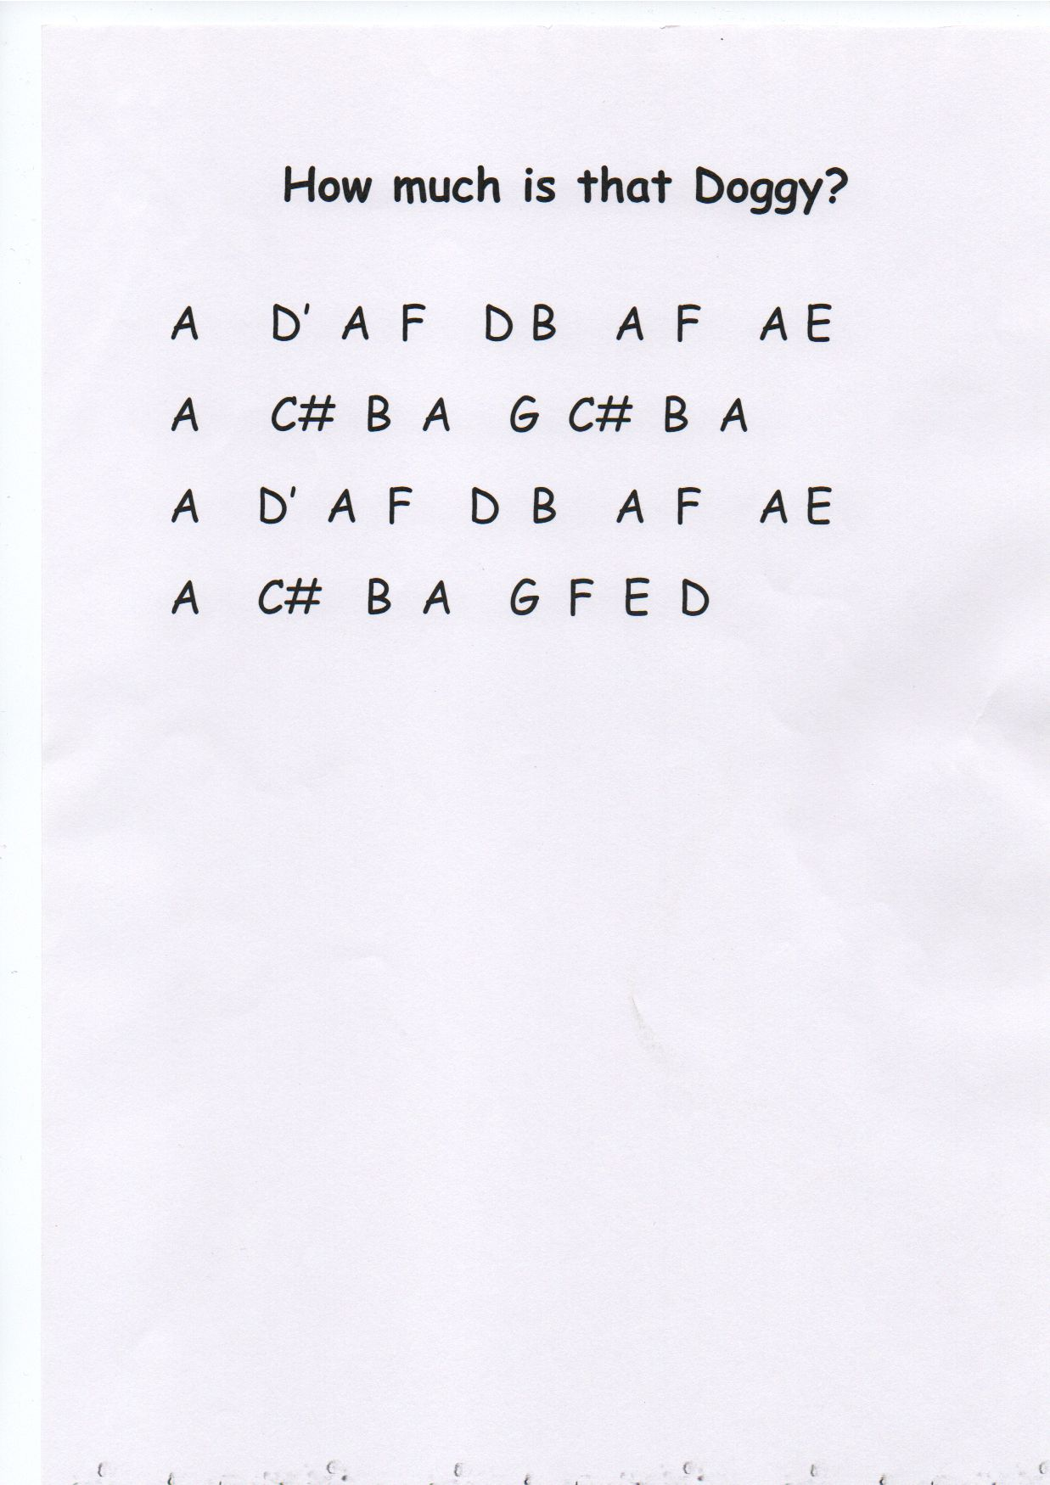

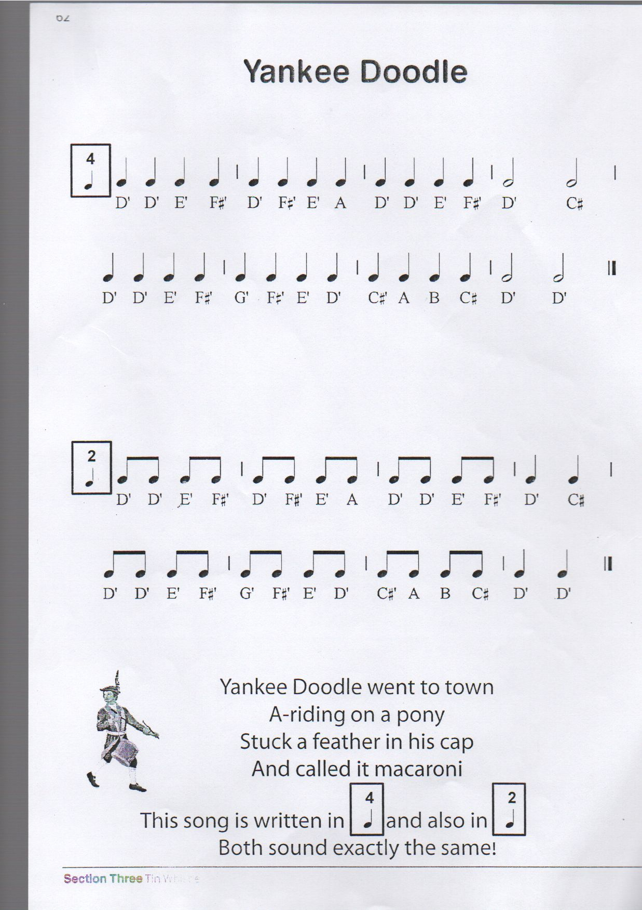

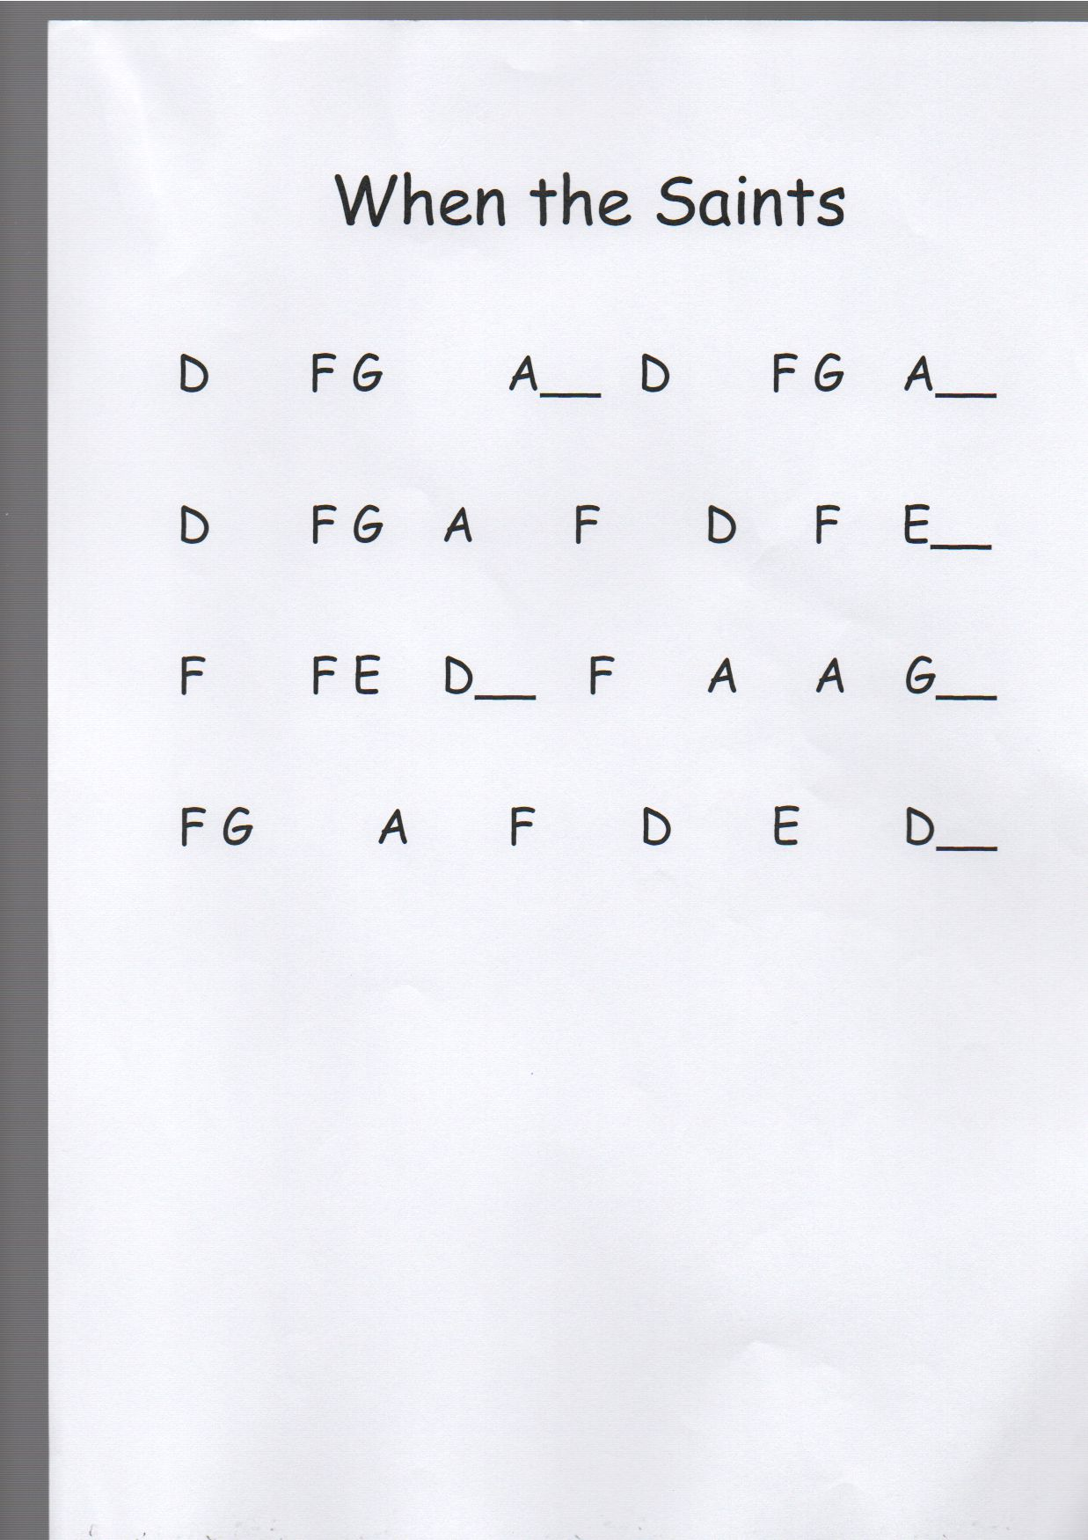

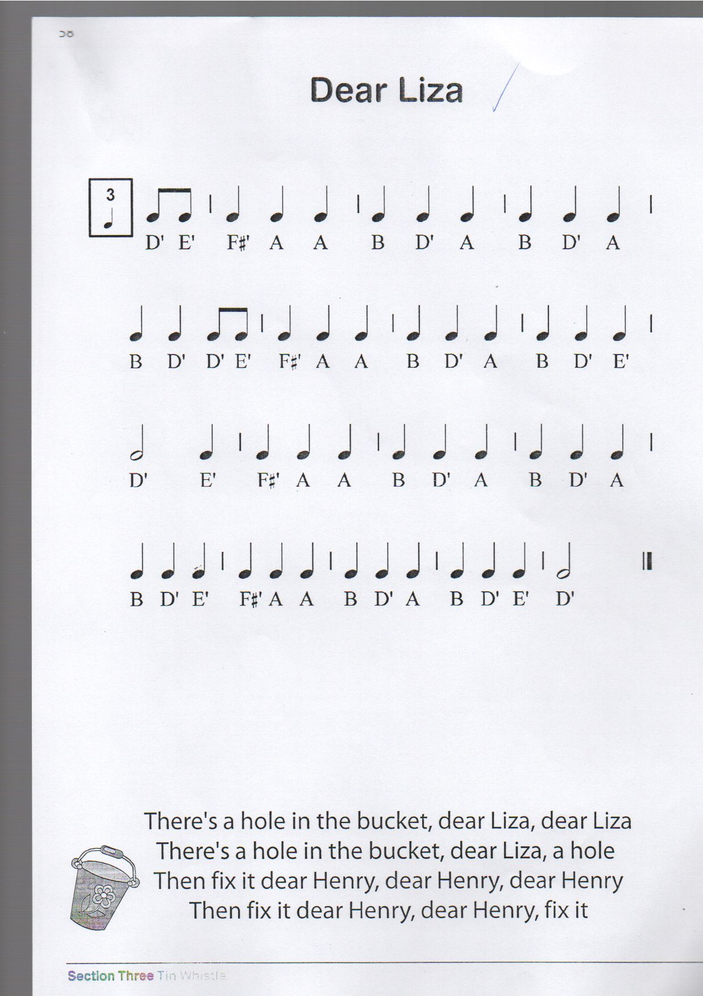

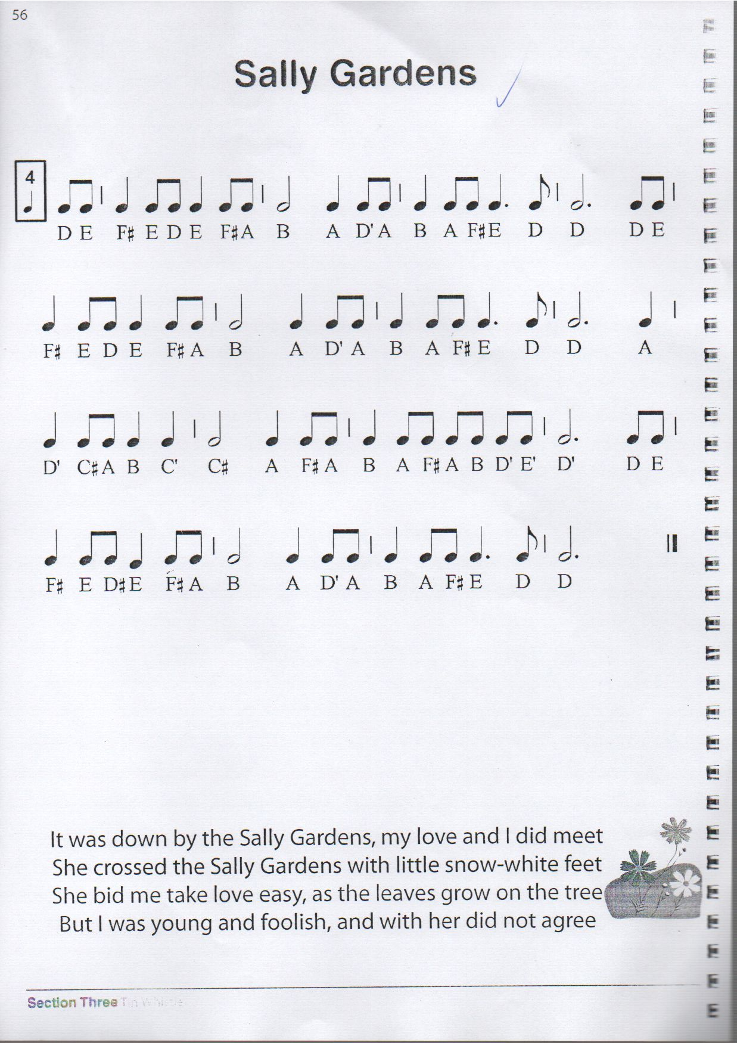

Rudolph the Red Nosed Reindeer
A BA F# D’ B A AB AB A D’ C#
G AG E C# B A AB AB A B F#
*A BA F# D’ B A AB AB A D’ C#
G AG E C# B A AB AB A E’ D’*
B B D’ B A F# A G B A G F#
E F# A B C# C# C#
D’ D’ C# B A G E .......
Play the notes in between the stars to finish

