- PARENTS COUNCIL ANNUAL
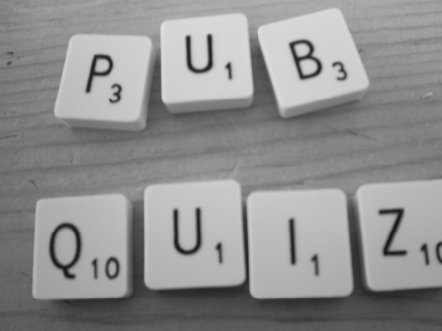

Treacy’s Bar and Restaurant,
The Heath
Friday 23rd February
@ 9.30 p.m.
4 people per table
€40 per table
Great Prizes to be won on the night
