PARENTS COUNCIL ANNUAL
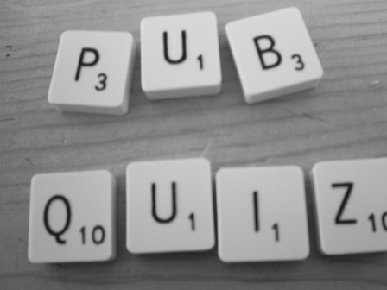

Treacy’s, The Heath
Friday 27th February
@ 9p.m.
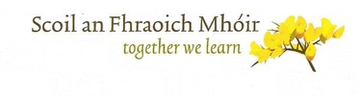
4 people per table
€10 per person

