

7 week GROUP programme

(4 weekly sessions of 2 hours, followed by 2 weeks where you practice Triple P at home with support phone call sessions, we meet as a group for final session)

|  |  |  |
| --- | --- | --- |
| **Date** | **Time** | **Location** |
| **Tuesday 28th Jan 20** | **7-9pm.** | **Mountmellick Family Resource Centre.** |
| **Wednesday 29th Jan 20** | **10-12md** | **Portlaoise Education Centre Block Road.** |

**Triple P 2hr Workshops**

Managing Fighting & Aggression

|  |  |  |
| --- | --- | --- |
| Tuesday 24th March 20 | 7-9pm. | **Portlaoise Education Centre, Block Road Portlaoise.** |

**Dealing with Disobedience**

|  |  |  |
| --- | --- | --- |
| **Tuesday 31st March 20** | **10-12md** | **Mountmellick Family Resource Centre** |
| **Tuesday 31st March 20** | **7-9pm.** | **Mountmellick Family Resource Centre.** |

Triple P Programmes give parents tips and strategies to cope positively with the challenges of raising children…..making family life more enjoyable!

**Please contact our office to book your FREE place**

**Midlands Area Parenting Partnership**

**Phone: 090 6447111/ Deirdre 0860274837/Sinéad 0868215102**





Tel ( 090) 64 47111

**Triple P Positive Parenting** 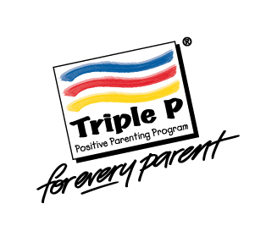

**Free courses for parents and carers of children aged 2-10 years**