Junior Infant Wellbeing Week – 15th – 19th June 2020
The following are some suggestions you might do this week, please feel under no pressure, pick and choose activities that suit you.
Monday | Tuesday | Wednesday | Thursday | Friday
Yoga  Cosmic Yoga  Complete ‘The Very Hungry Caterpillar’ Yoga video  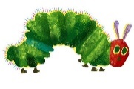 | Yoga  Cosmic Yoga  Complete ‘Coco the  Butterfly’ Yoga video | Yoga  Cosmic Yoga  Complete ‘We’re Going on a Bear Hunt’ Yoga video  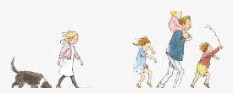 | Yoga  Cosmic Yoga  Complete ‘Popcorn and the Pirates’ Yoga video | Yoga  Cosmic Yoga  Complete ‘Pedro the Penguin’ Yoga video.
Story Time  Listen to the story ‘The Big Bag of Worries’. Draw some pictures of things that worry you and tell me about your picture. | Mindful Colouring  Play some relaxing music and chill out while you colour!  Pick a page from your Rainy Days Book! Take a picture and upload it to Seesaw so I can see! | Story Time  Listen to the story ‘Have you Filled a Bucket Today?’  Can you think of some things you could do to become a bucket filler? | Glitter Jar  Make your own glitter jar. If you feel worried, give that jar a shake, watch the glitter swirl around and then settle calmly at the bottom. | Story Time  Listen to the story ‘Don’t Worry William’.  Draw a picture of your favourite part of the story.,
Meditation  Rainbow Meditation – Make yourself comfortable, close your eyes and relax with this rainbow meditation. | Meditation  Butterfly Body Scan – Try this nice relaxing and calming meditation. | Meditation  Sitting Still Like a Frog – Can you pretend you are a frog and sit still just like they do? | Meditation  The Gratitude Tree – take some time to relax and think about all the things you are thankful for in your life. | Meditation  Mindfulness of the Senses – take some time to really wake up your senses!
Art  Rainbow Heart activity – make a rainbow heart for someone to show them how much you care for them. | Art  Draw a butterfly or try some butterfly printing. | Random Act of Kindness  Can you carry out some random acts of kindness today? I bet you it will make you feel really happy. | Art  Create your own Tree of Thanks . | Senses Scavenger Hunt Can you use all five senses to complete all the tasks on our five senses scavenger hunt?

Resources:
Cosmic Yoga – Please find the links below for each Cosmic Yoga activity:
- The Very Hungry Caterpillar – https://www.youtube.com/watch?v=xhWDiQRrC1Y
- Coco the Butterfly – https://www.youtube.com/watch?v=pT-s1-phgxs
- We’re Going on a Bear Hunt – https://www.youtube.com/watch?v=KAT5NiWHFIU
- Popcorn and the Pirates – https://www.youtube.com/watch?v=T_0P5grVoyg
- Pedro the Penguin - https://www.youtube.com/watch?v=Rzw-Oir8UPw

Story time – Please find the links below for read alouds of each story:
- The Huge Big Bag of Worries - https://www.youtube.com/watch?v=NbcswBYnmeQ
- Have you Filled a Bucket - https://www.youtube.com/watch?v=3EuemNAo6XE
- Don’t Worry William - https://www.youtube.com/watch?v=JG-ocltu5i4

Meditation – the links below will open up the short meditation videos:
- Rainbow Meditation - https://www.youtube.com/watch?v=zyjjz-Q2fDA
- Butterfly Body Scan - https://www.youtube.com/watch?v=56_8aK3cLEA
- Sitting Still Like a Frog - https://www.youtube.com/watch?v=m5RkzsbaPiE
- The Gratitude Tree - https://www.youtube.com/watch?v=64QzBuhsyuk
- Mindfulness of Senses - https://www.youtube.com/watch?v=AFdZabPF0fE

Random Acts of Kindness – Can you become a bucket filler and carry out some random acts of kindness?

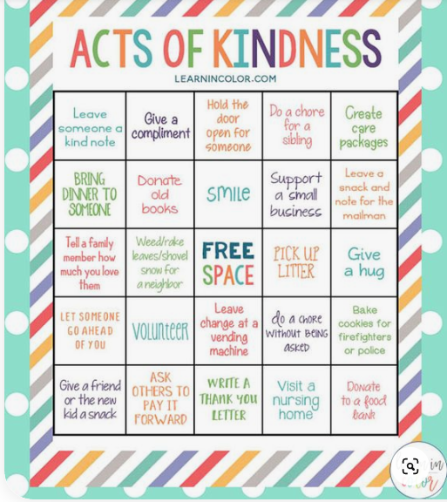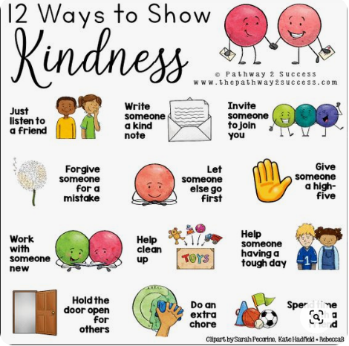

Draw your own butterfly – follow each step to draw your own butterfly.
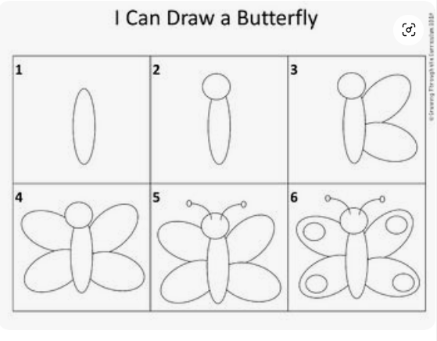

Gratitude Tree (Tree of Thanks Activity) instructions:
